Mok Nga Yau (Angie) 25 J.1 Faith
In the park
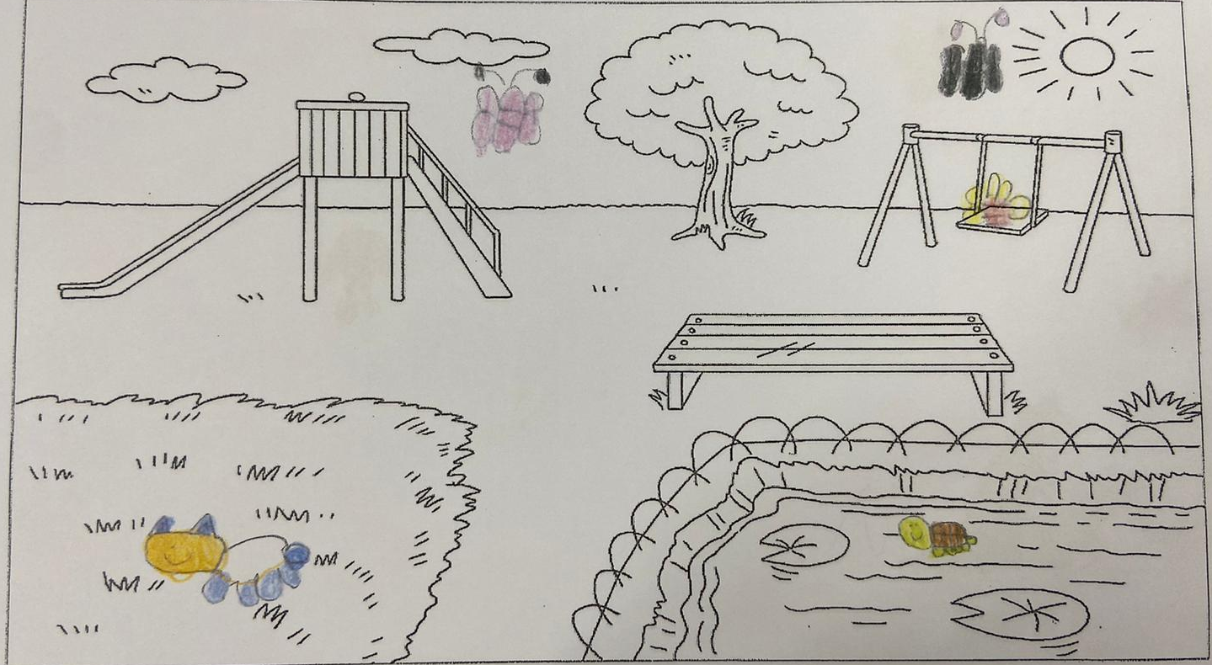

I can see a bee.
It is on the swing.
It is red and yellow.
I can see a turtle.
It is in the water.
It is green and brown.
I can see a cat.
It is on the grass.
It is white, blue and orange.
I can see two butterflies.
They are in the sky.
They are pink and black.

